Manual Steps to be followed, please follow the sequence

1. Payment Request
2. Identify the PR Request creator LANID and assign role AP000035.
3. Add countries in string table “ANZPYRC1” as below so that required LANID data will be generated for UK ad THA after running the processes ANZ_PAY_REC and ANZAUTHUPD
4. COUNTRY1 -> THA
5. COUNTRY2 -> GBR
6. Role AP000036 is dynamic role which should be assigned to above users.
7. Role AP000040 should be assigned to Payment Request requester.
8. Voucher Approval
9. Identify and assign following roles to specific users who are responsible for GST Control and QA Check Approval for UK in following manner
10. GST Control
11. AP000045
12. AP000047
13. QA Check
14. AP000046
15. AP000047
16. Identify and assign following roles to specific users who are responsible for GST Control and QA Check Approval for Thailand in following manner
17. GST Control
18. AP000043
19. AP000047
20. QA Check
21. AP000044
22. AP000047
23. Creating the User-lists for GST/VAT and QA Control for UK and THA.
24. Please keep the description as VAT though the userlist name is GST

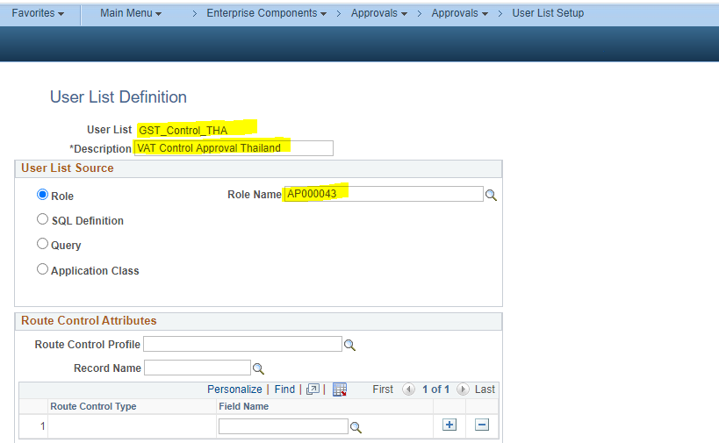

1. Please keep the description as VAT though the userlist name is GST

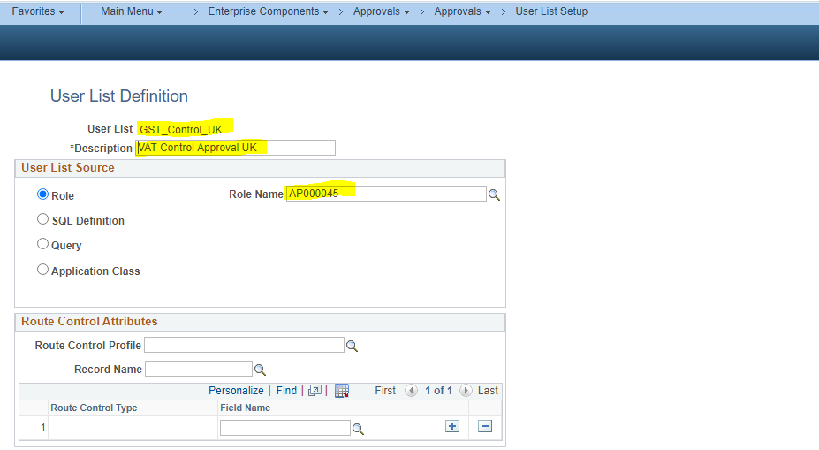

1. QA userlist for THA

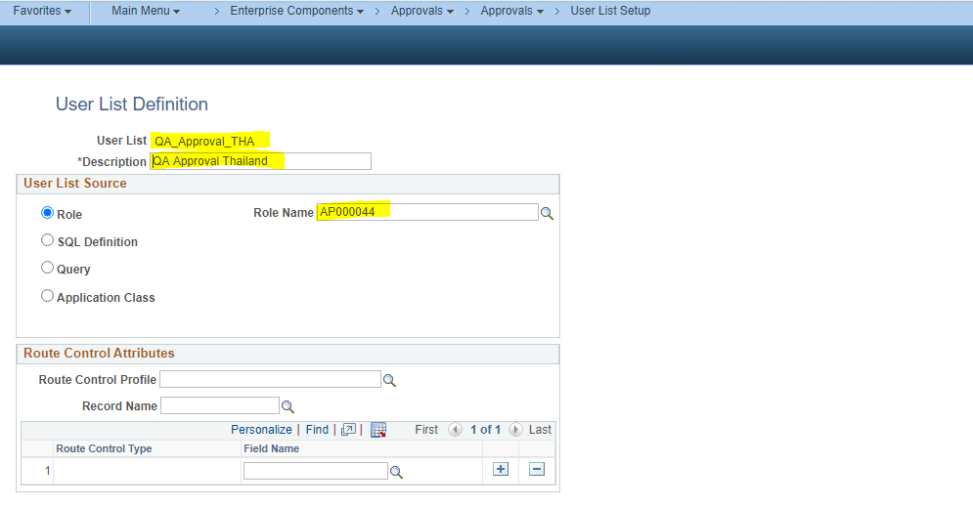

1. QA userlist for UK

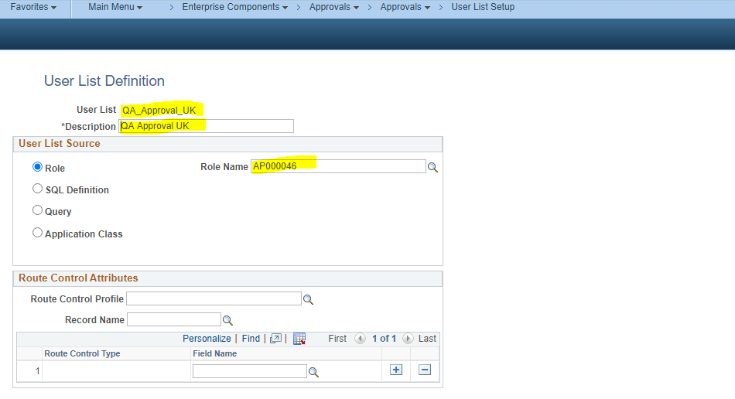

1. Updating Voucher Approval Setup from “Pre-approved” to “Approval Framework” at “Payable Options” as per the snaps below
2. UK

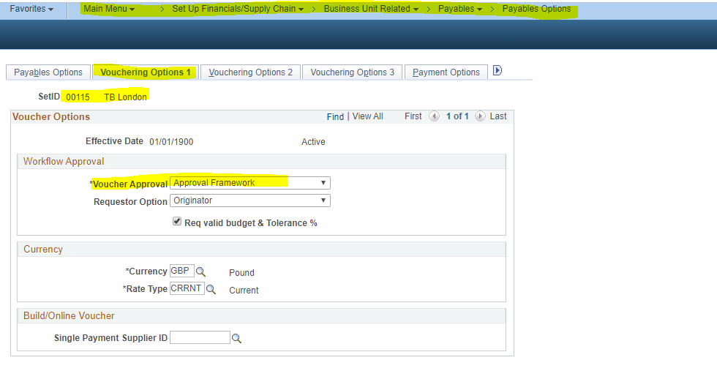

1. Thailand

